PRIORITIES
IMPORTANT & URGENT
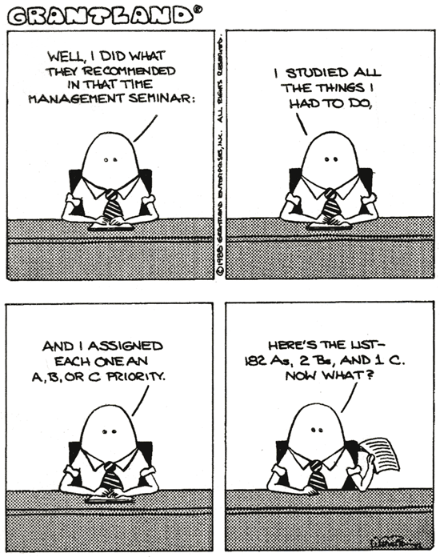

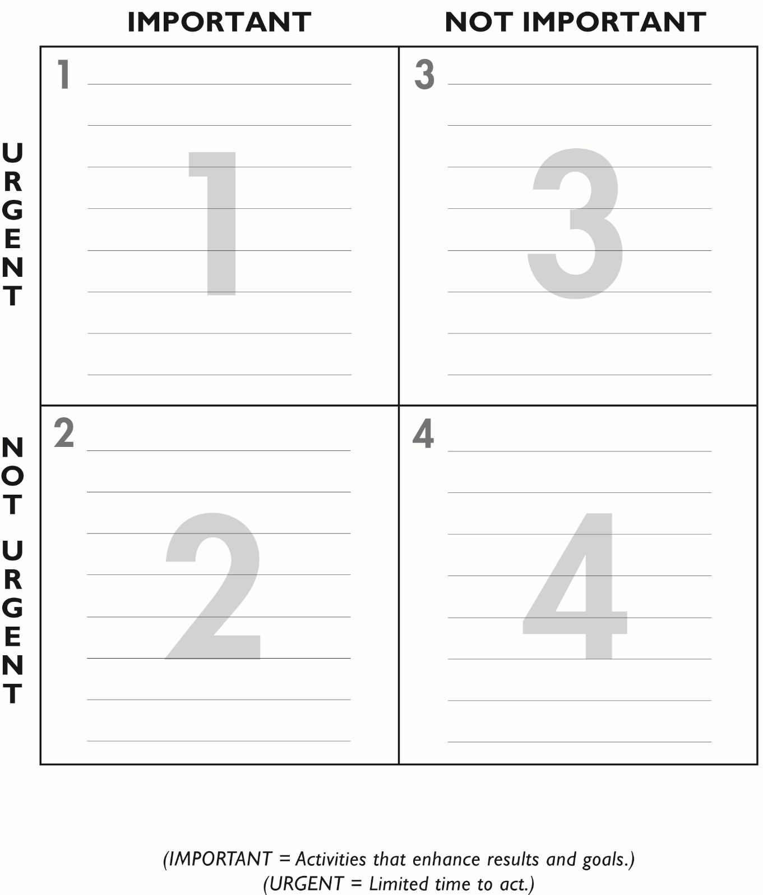
DO PLAN

DELEGATE ELIMINATE

